**Day 5 Lab Assignments**

**Bonus lab:**

**Event:**

1. Make a countdown starts from 5 only when pressing enter.
2. Make a game that allows user to move a car to the left, right, top and bottom
3. Make a registration form (you can re-use the registration form you did before) as the following:
   1. Form fields:
      1. Full Name
      2. Email (input type: email)
      3. Password
      4. Repeat password.
      5. Register button, which redirects to another page saying: “Thank you, Full Name for registering in our website”.
   2. After every time user finish writing his full name, email and leaves the input (lost focus), if full name wasn't in correct format (more than 3 letters) or email not in valid pattern Change the background color of the input when to: yellow, else if full name or email was in correct format return back the background color to white .
   3. For Password, when the user leaves field, we need to validate that they’re required, and they’re identical (The same), and if they’re not the same show text besides it saying “password and repeat password should be the same”; remove the validation message when the user enters it correctly.
   4. Prevent him from submitting if full name or email are invalid
4. Add “Show password” button besides the password input that changes the input type to “text” when checked, and changes it to “password” when unchecked. *[use: document.getElementById("myInput").type].*

Make the final design of the textbox like the following image

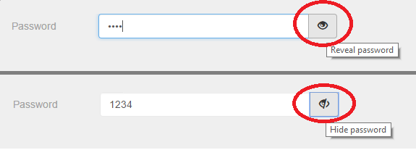

1. Make nested div tags and handle on click event on each one to do something. Notice what will happen. *search for event Bubbling and stopPropagation()*

**AJAX:**

1. Use JS to call API that retrieves products data (**WITHOUT CLICKING ANY BUTTONS)** when the page loads: title, price, image from the following fake web API: <https://fakestoreapi.com/products/>
2. Make an input where the user can enter product id, and press a display button and then display the product details with description with the given ID using this API URL <https://fakestoreapi.com/products/>*theSelectedID*
3. Use this web API: <https://jsonplaceholder.typicode.com/posts> to return all posts data, and make a dropdown list and fill it with posts title returning from the API. (Loop on them and display all posts title).
4. When user selects specific post (onchange event), display its body below the dropdown list.
5. Make another dropdown list and fill it with users’ names from this API <https://jsonplaceholder.typicode.com/users> . when user selects specific name display his posts using this API URL [https://jsonplaceholder.typicode.com/posts?userId=](https://jsonplaceholder.typicode.com/users/userId=the)*theSelectedID*

Extra bonus:

1. Create a simple E-commerce website from 2 pages:
   1. First page displaying products (use this API: <https://fakestoreapi.com/products>) in a list like the following image:

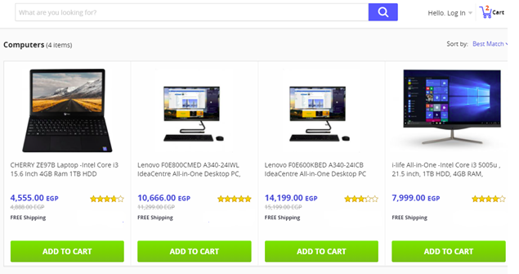

* 1. Use cookies or local storage to store the ID of the product, when user clicks (Add to Cart).
  2. In the first page add a link (like in the upper part of the previous image) to the second page (Shopping Cart), that lists the products added by the user (user can edit items count and can delete items), and calculate the total price and display it on the page (You’ll need to run your product from any local server so you can access cookies or local storage in all website page, for example you can use live server extension in Visual Studio code).

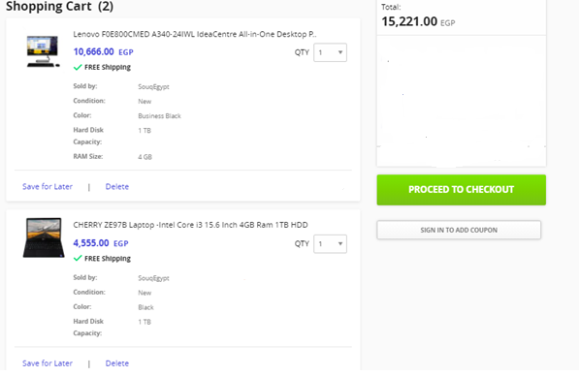

* 1. Make a details page for each product, when opened display all details of the selected product (Use this API: [https://fakestoreapi.com/products/*id*](https://fakestoreapi.com/products/id) ).
  2. Congratulations, you just finished your first pages in a simple E-commerce websiteJ.